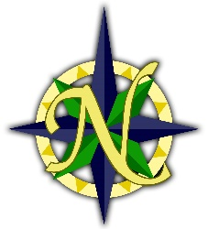
PRESS RELEASE For Immediate Release

Northshore Christian Academy
5700 – 23rd Drive West Contact:
Everett, WA 98203 Holly Leach, Superintendent
www.nca.school Phone: 425.322.2361
Phone: (425) 407-1119 Fax: (425) 322-2386 Email: hleach@nca.school

NORTHSHORE CHRISTIAN ACADEMY IS AWARDED A PRESTIGIOUS 2019 NATIONAL BLUE RIBBON SCHOOL BY THE U.S. DEPARTMENT OF EDUCATION
NCA is the Only Private School on the West Coast to Receive Coveted 2019 Award
Everett, WA – October 3, 2019: Northshore Christian Academy (NCA) in Everett, Washington, has been officially named a National Blue Ribbon School (NBRS) by the United States Department of Education. This year, NCA is one of only 50 private schools in the Nation, and the only private school in the State of Washington and the entire West Coast, to receive this highly sought-after and esteemed award. U.S. Secretary of Education, Betsy Devos, congratulated NCA saying, “As a National Blue Ribbon School, your school demonstrates what is possible when committed educators hold all students and staff to high standards and create vibrant, innovative cultures of teaching and learning”.
Nominated under the NBRS ‘Exemplary High Performing School’ category by the Council for American Private Education (CAPE), NCA first had to meet strict requirements which included standardized testing scores in the top 15% of the Nation in the areas of English/Reading and Mathematics.
Representing NCA, Superintendent Holly Leach will attend the official NBRS Awards Ceremony in Maryland, on November 15-16, 2019, where NCA will be publicly recognized and presented with an official plaque. Leach stated, “In addition to our high test scores, there are three key areas where NCA stands out among schools Nation-wide: Our innovative learning programs; our schools culture partnering with parents and community leaders; and our collaborative teams’ approach.”
NCA is planning two Award-Reveal Celebration Assemblies on Wednesday, Nov. 20, 2019 which will be attended by students, families, and local dignitaries, possibly including Everett Mayor, Cassie Franklin. Prior to this event, on Monday Nov. 18, 2019, Washington State Senator John McCoy and House Representatives Mike Sells and June Robinson have been invited to NCA to learn about the details of the NBRS Award and to tour the school. Watch for more details here: nca.school/blue-ribbon-school
About the National Blue Ribbon Award
Since 1982, the NBRS Program has recognized public and private elementary, middle, and high schools based on their overall academic excellence or their progress in closing achievement gaps among student subgroups. Every year the U. S. Department of Education seeks out and celebrates great American schools demonstrating that all students can achieve to high levels. The NBRS award affirms the hard work of students, educators, families, and communities in creating safe and welcoming schools where students master challenging content. The NBRS flag gracing an entry is a widely recognized symbol of exemplary teaching and learning. To view NCA’s award, go to NCA Blue Ribbon Award Official Page.
What Makes NCA Stand Out
NCA blends excellence in fine arts and foreign languages which includes K-4th grades music education with annual performance concerts, musical plays, chapel presentations and after-school lessons. All 5th-8th graders participate in one or more of the 16 bands, orchestras, choirs, art, chapel, or drama classes offered. In 1st-8th grades, foreign language instruction (Spanish, German, Mandarin) and a public speaking program build communication skills. Their STEM (Science, Technology, Engineering & Mathematics) programs offers weekly K-8th grades engineering classes where science and math learning come alive in the engineering lab by tackling real life problems. Early advancement is offered in Math classes. Finally, all academics are interwoven and filtered through Christian faith instruction, daily Bible classes, weekly chapel, a caring culture and community service projects.
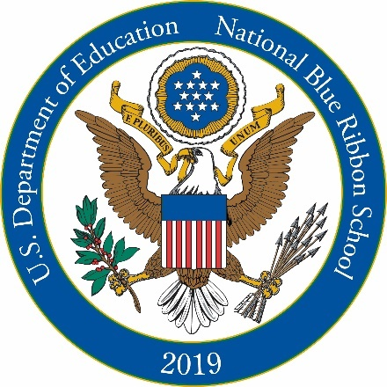
Established in 1995, NCA is a Ministry of Northshore Christian Church, and provides a high-quality, well rounded education for over 800 students in K-8th Grades and licensed Early Learning Center. Visit our website at www.nca.school or Twitter NCA_Schools and Facebook @NorthshoreChristianAcademy.
###

For Immediate Release - October 3, 2019

